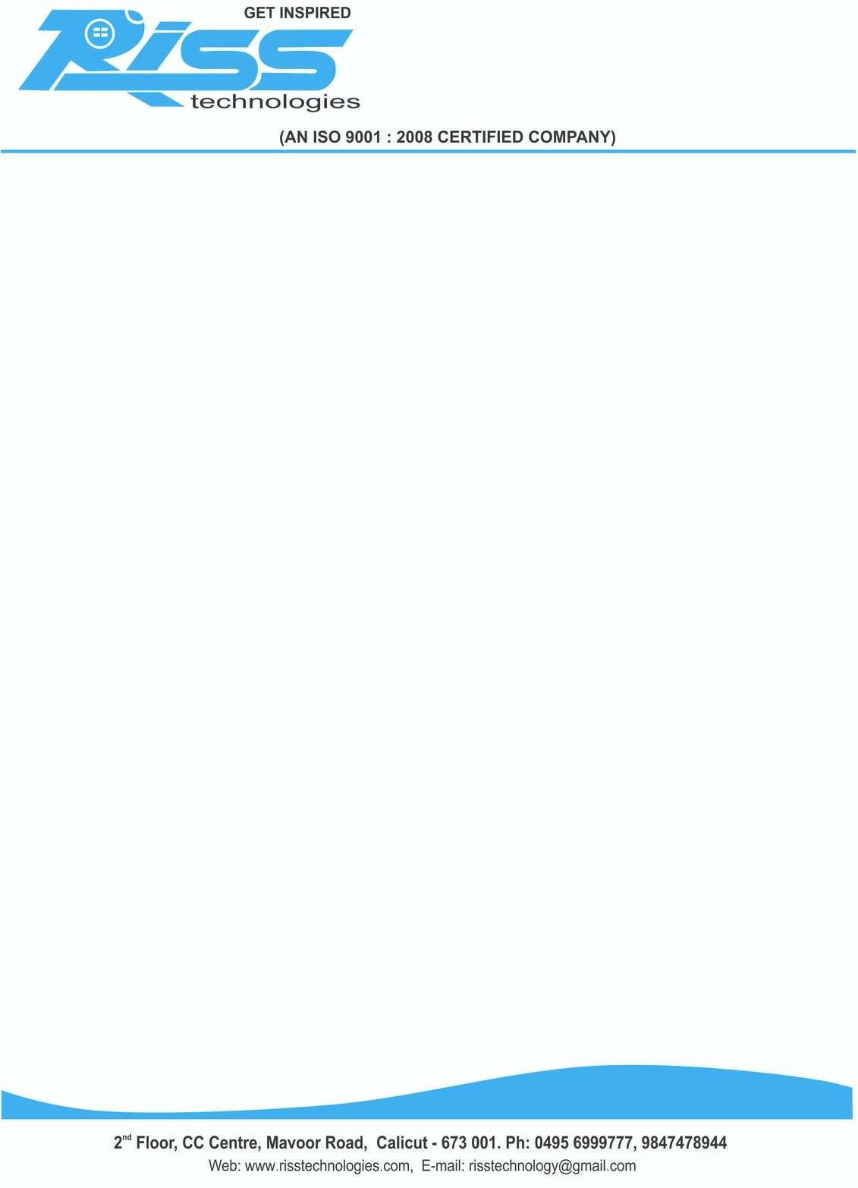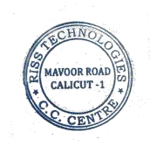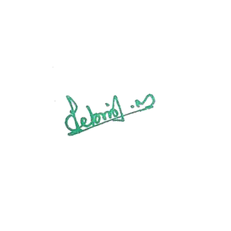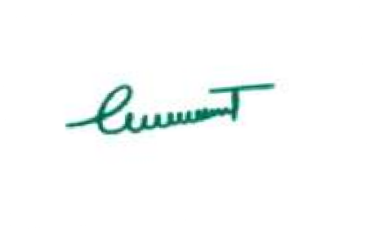

Date: 18/03/2024

# CERTIFICATE

This is to certify that **MOHAMMED RASEEN M** (**Reg. No: MSAVBCA049)** student of

# MAJLIS ARTS AND SCIENCE COLLEGE, PURAMANNUR, VALANCHERY has

successfully completed his academic project entitled **“DRIVER VIGILANCE SYSTEM”** in **PYTHON with JAVA** under the guidance of our senior developers during the period **JUNE 2023 to MARCH 2024.**

During this period he was found hardworking, punctual & efficient. We wish him a successful future.

RISS TECHNOLOGIES

PROJECT MANAGER